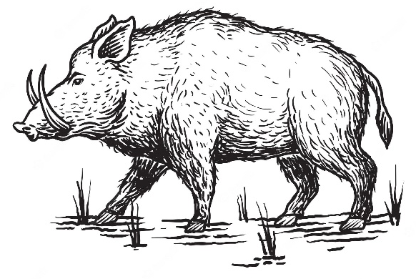
Wild Boar Live 2023

Basic Info
Date: 29th July 2023
Location: The Pludds Village Hall, The Pludds, Ruardean, GL17 9UQ

Doors Open: 8.00am
Start Time: 9.00am
Sections: Original Finish, Custom Finish, Plastic CTF, Bendy CTF, ARC & Workmanship
Charity: MND Association - https://www.mndassociation.org/
Contact: competitions@chestnutridge.co.uk
We will be applying for BMECS qualification.

The Cost
Full Table: £20.00
Half Table: £12.50
Proxy: £5.00
You are responsible for finding your own proxy shower.
Please see below for information on how to pay.
Sales Table (non-shower): £5.00
Showers are entitled to sell items at lunchtime at no additional cost. Sales tables for businesses will not be in the main hall but the entrance hall (by the kitchen) or small hall depending on space.
If you are showing and also want a sales table please be aware that it is not possible to have this next to your table! You are more than welcome to buy one but you will need to find someone to man it, or be prepared to run back and forth.

Entry Terms
- Entry fees are 100% non-refundable under any circumstances – once you have paid you have made a commitment to attend the show
  - Excess entry fees will be donated to the chosen charity
- Failure to attend (either dropping out last minute, not turning up on the day etc) could result in your place being forfeited at future shows without a refund.
- No deposits are available – full payment only secures your place.
All entrants will get one full table (or half table if requested), please make sure to keep your boxes under your table!
These rules are in place to ensure that everyone who pays for a place actually attends, we want the places to go to those who actually plan on attending and showing!
There are 20 full spaces available and five extra half-spaces. Entries are sold on first-come first-serve. We have additional space for sales.

The Schedule

Original Finish
- Arabian
- Thoroughbred
- Iberian
- Warmblood & Sport Horse
- Other Purebred Horse

Light Horse Championship
- American Quarter Horse
- Appaloosa
- Paint Horse
- Gaited
- Other American

American Championship
- UK Heavy Horse
- European Heavy Horse
- Vanner & Cob
- Carriage
- Other Purebred Heavy Horse

Heavy Horse Championship
- Welsh
- Other British Native Pony
- Other European Pony
- Pony Types (e.g. Riding Pony, Hunter Pony etc.)
- Other Purebred Pony

Pony Championship
- Partbred Arabian
- Other Partbred Light Horse
- Partbred American
- Partbred Heavy Horse
- Partbred Pony

Partbred Championship
- Other Equine
- Decorator
- Fantasy
- Horse Youngstock
- Pony & Other Youngstock

Other Championship

Original Finish Championship

Custom Finish
- Arabian
- Thoroughbred
- Iberian
- Warmblood & Sport Horse
- Other Purebred Horse

Light Horse Championship
- American Quarter Horse
- Appaloosa
- Paint Horse
- Gaited
- Other American

American Championship
- UK Heavy Horse
- European Heavy Horse
- Vanner & Cob
- Carriage
- Other Purebred Heavy Horse

Heavy Horse Championship
- Welsh
- Other British Native Pony
- Other European Pony
- Pony Types (e.g. Riding Pony, Hunter Pony etc.)
- Other Purebred Pony

Pony Championship
- Partbred Arabian
- Other Partbred Light Horse
- Partbred American
- Partbred Heavy Horse
- Partbred Pony

Partbred Championship
- Other Equine
- Decorator
- Fantasy
- Horse Youngstock
- Pony & Other Youngstock

Other Championship

Custom Finish Championship

Plastic CTF
- Arabian & Partbred Arabian
- Thoroughbred
- Warmblood & Sport Horse
- Other Purebred Horse
- Other Partbred Horse

Light Championship
- American Quarter Horse
- Paint & Appaloosa
- Gaited
- Other Purebred American
- Partbred American

American Championship
- UK Heavy Horse
- European Heavy Horse
- Cob & Vanner
- Other Purebred Heavy Horse
- Other Partbred Heavy Horse

Heavy Horse Championship
- British Native Pony
- European Native Pony
- Other European Pony
- Other Purebred Pony
- Other Partbred Pony

Pony Championship
- Other Equine
- Fantasy
- Decorator
- Horse Foals
- Pony Foals

Other Championship

Plastic CTF Championship

Artist Resin
- Arabian & Partbred Arabian
- Thoroughbred
- Warmblood & Sport Horse
- Other Purebred Horse
- Other Partbred Horse

Light Championship
- American Quarter Horse
- Paint & Appaloosa
- Gaited
- Other Purebred American
- Partbred American

American Championship
- UK Heavy Horse
- European Heavy Horse
- Cob & Vanner
- Other Purebred Heavy Horse
- Other Partbred Heavy Horse

Heavy Horse Championship
- British Native Pony
- European Native Pony
- Other European Pony
- Other Purebred Pony
- Other Partbred Pony

Pony Championship
- Other Equine
- Fantasy
- Decorator
- Horse Foals
- Pony Foals

Other Championship

Artist Resin Championship

Bendy CTF
- Arabian & Partbred Arabian
- Thoroughbred
- Warmblood & Sport Horse
- Other Purebred Horse
- Other Partbred Horse

Light Championship
- American Quarter Horse
- Paint & Appaloosa
- Gaited
- Other Purebred American
- Partbred American

American Championship
- UK Heavy Horse
- European Heavy Horse
- Cob & Vanner
- Other Purebred Heavy Horse
- Other Partbred Heavy Horse

Heavy Horse Championship
- British Native Pony
- European Native Pony
- Other European Pony
- Other Purebred Pony
- Other Partbred Pony

Pony Championship
- Other Equine
- Fantasy
- Decorator
- Horse Foals
- Pony Foals

Other Championship

Bendy CTF Championship

Workmanship
- Bay
- Black
- Chestnut
- Grey
- Other Colour

Solid Championship
- Pinto
- Spotted
- Sabino
- Roan
- Other Part Colour

Part Colour Championship
- Cream Dilute
- Duns
- Other Dilutes
- Other Equines
- Fantasy & Decorator

Other Colour Championship

Workmanship Championship

Lunchtime Fun Classes
One entry per class. Open to all (showers & non-showers). They will be judged according to the marshmallow method.
- Best Hog (pigs & wild boar)
- Forest Scene
- Made from wood (can be a model, prop, tack or anything else)
Special Charity Class - £1.00 donation to be given to MND Association
- Best American Quarter Horse

Donations
This is a charity live so all donations will be greatly received. We are looking for:
- Raffle Prize Donations
- Rosettes/Trophies
- Donation Sales Donations
- Certificates
- Food
- Anything else you think you can donate

Raffle and Sales
There will be a raffle at lunch time – tickets will be priced at £1.00 per strip.
There will be space for sales at lunch

Rules and Entry
- This is an open show and therefore anyone may enter.
- 3 entries per entrant per in hand class
- 2 entries per workmanship class
- Each horse can only enter one breed class.
- Halters are allowed in breed classes but please no other tack or handlers
- Riders/handlers are mandatory in all performance classes with the exception of scene where not appropriate.
- No running, dogs or smoking is permissible in the hall.
- Take care when placing or removing horses from the ring.
- Do not touch or move any other model unless you have express permission to do so.
- Poor sportsmanship will not be tolerated. You will be asked to leave with no refunding of entry fee.
- The judge’s decision is final.
- Any queries regarding the show or classes should be directed to the show holders.
- Children under 13 years must be accompanied by an adult.
- Please sit at your own table throughout the show, do not place models on the floor or move them to another showers table.
- The organiser’s. their agents, nor the owner of the hall, will be held responsible for any theft, damage or personal injury.
- Please bring a packed lunch – snacks and drinks will be provided
- The show holder reserves the right to ask anyone to leave the show at any time without a refund of their entry fee. We WILL NOT tolerate poor sportsmanship, at all, ever.

Prizes & Sponsorship
- There will be certificates to sixth place
- There will be rosettes or trophies for champions
- Overall champions will get rosettes and possibly something else
  - Sponsorship Costs
- Class - £5.00
- Section - £15.00
- Championship - £10.00
- Alternatively if you donate the rosettes/prizes for a section/class/championship I will allow you to place advertising
- Sponsors get advertising in the show pack

Contact & Payment
Please make cheques payable to: Catriona Harris
PayPal payment (personal payment owed): rabbit.queen@hotmail.co.uk
  - Contact Details
Name: Catriona Harris
Email: competitions@chestnutridge.co.uk

Address:
Catriona Harris
Allendale
Plump Hill
Mitcheldean
Gloucestershire
GL17 0ET

Directions
Address:
The Pludds Village Hall
The Pludds
Ruardean
GL17 9UQ

Directions from M50:
- At the roundabout at the end of the M50 take the first exit, onto A40
- Take the second exit at the roundabout (straight across) onto A40
- Take the second exit at the roundabout (straight across) onto A40
- After about 7 miles turn left towards Goodrich
- Continue through Goodrich until you reach the end of the road, turn left onto the B4229
- Continue over the river until you reach the end of the road, turn right onto the B4234
- After about 4 miles turn left towards the Royal Spring pub onto Venton Lane
- Continue until the end of the road and then turn left onto Townsend
- Take the first right onto Eddys Lane (just before the bus stop)
- When you reach the fork in the road go left onto the High Street
- Take the second left up the track to the front of the hall
- You will be asked to unload your car at the front and then move your vehicle to the car park at the rear of the hall (or onto the grass if the weather is good). Only those with a disabled parking pass can remain parked at the front as only a few vehicles will fit here.
Directions from Gloucester:
- Leave Gloucester on the A40 past Over Farm
- At the first roundabout following Over Farm take the second exit (straight over) to continue on A40
- Continue on the A40 until you hit a set of traffic lights by an old garage. Turn left towards Longhope
- Continue on this road until you hit Mitcheldean
- At the mini roundabout take the first exit onto New Road towards Plump Hill
- Drive past my house (can you spot my cave?) continue on the A4136
- After about 3.5 miles turn right onto the Pludds Road (if you pass the petrol station on the right you have gone too far, turn around and take the second left)
- Continue on this road until you read The Pludds, the hall is the third turning to the right. It is signposted and pretty obvious.
- Take the track up to the hall
- You will be asked to unload your car at the front and then move your vehicle to the car park at the rear of the hall (or onto the grass if the weather is good). Only those with a disabled parking pass can remain parked at the front as only a few vehicles will fit here.
Look a map!
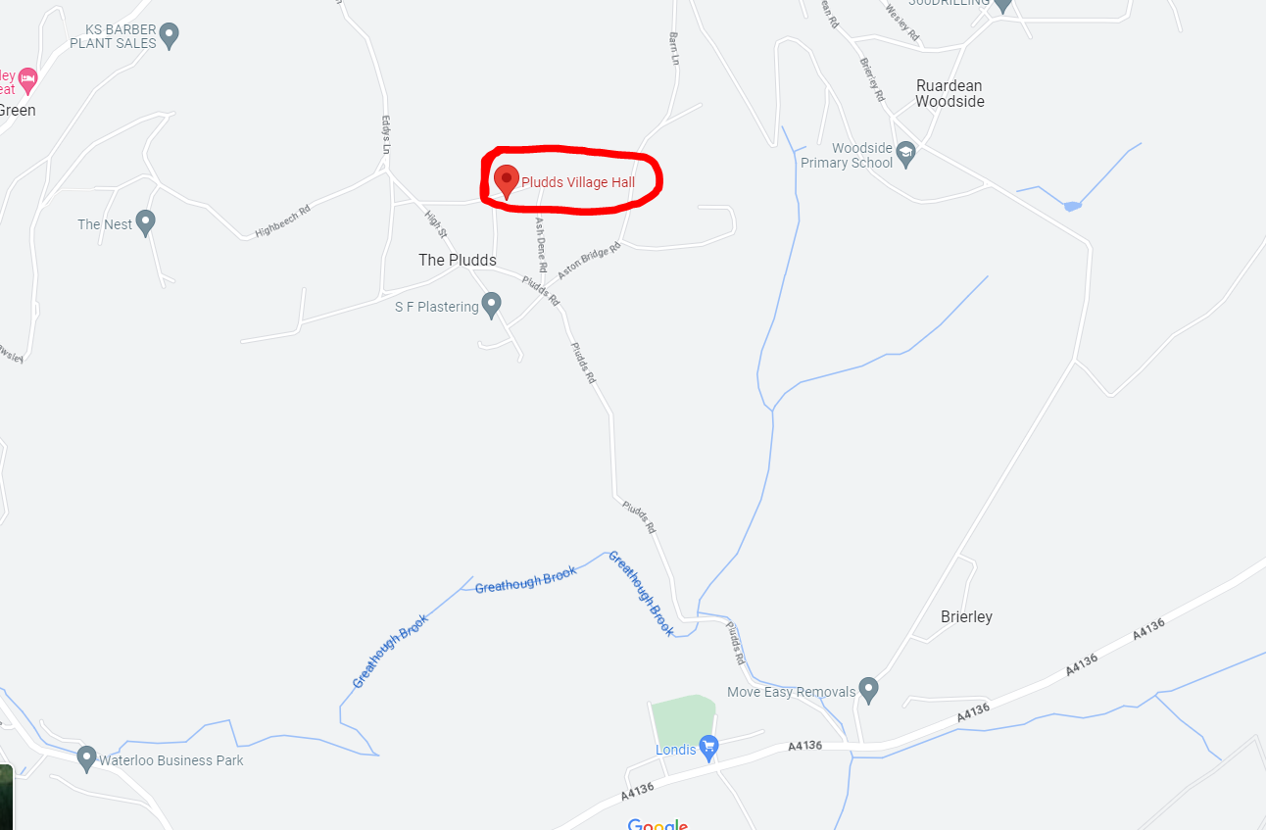
The hall is a bit in the back and beyond! The roads to it are narrow and steep (thinking driving in Greece and you’ll get a good idea). If you don’t like narrow roads maybe get someone else to drive!

Where Should I Show My Model?

The Sections
Original Finish
- Breyer
- Copperfox
- Peter Stone
- Hartland
- All Commercial Resin/China
  - E.g. Beswick, Breyer Resins, Royal Doulton, Royal Worcester, Northlight, Wade etc.
Custom Finish
- All customised plastic & commercial models
- E.g. custom Breyer, custom Schleich, custom Copperfox, custom Beswick, custom Northlight etc.
CTF
- Plastic CTF (including but not limited to):
  - Schleich
  - CollectA
  - Breyer Mini Whinnies
  - Magpie
  - Safari
  - WIA
- Bendy CTF (including but not limited to):
  - Julip
  - Custom Julip
  - RubberNedz
  - Equorums
  - Crystal Moons
  - Felties
  - Handmade
  - Plushies
Artist Resin/China
- All artist resin & china models
- Animal Artistry

