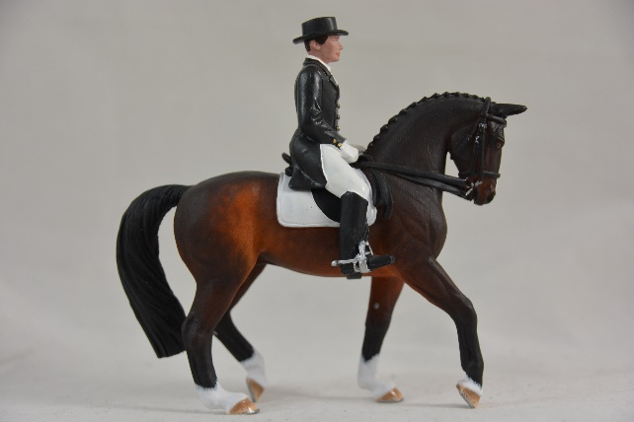
WEG Postal Show

This is a fun and free to enter postal show based around the World Equestrian Games 2018. It is open to everyone, no matter your location.
All you need to provide is information about the horse’s you are entering. It is judged on an entirely random basis.

Entry Fees
This show is completely free to enter.

How to Enter
To enter please email the entry form (at the bottom of this document) to competitions@chestnutridge.co.uk
Please make sure to include all the information needed.
You can enter a maximum of 10 horses/entries. Each horse can only enter one event. You can enter all 10 into one event or spread them out as you wish.
For team events e.g. driving you can supply a team name or list the four horse names. I have split up events with individual elements such as eventing into different classes to allow for more chances for people to win a rosette – horses can only enter one ‘element’

Dates
Opening Date: 1 September 2018
Closing Date: 15 September 2018

Class List
This show is open to all makes and models. The model must physically exist but does not need to be in good condition. You do not need to submit any information other than that on the entry form.
- Endurance
- Reining
- Dressage – Grand Prix
- Dressage – Grand Prix Special
- Dressage – Grand Prix Freestyle
- Eventing – Dressage
- Eventing – Cross Country
- Eventing – Show Jumping
- Paradressage – Grade I
- Paradressage – Grade II
- Paradressage – Grade III
- Paradressage – Grade IV
- Paradressage – Grade V
- Vaulting – Individual
- Vaulting - Freestyle
- Jumping – Speed
- Jumping - Individual
- Driving – Dressage
- Driving – Marathon
- Driving – Obstacle/Cones

Results
Results for this show will be generated by random.
We will be using www.random.org to generate results.
Results will be posted online and also emailed to entrants after the show.

Rules
- This show is open to all makes, scales and types of models. The model must physically exist but does not need to be in good condition
- Horses entered must be the appropriate breed, age and height
- Each horse must have all the information required on the entry form to be accepted
- Entry limits must be followed – maximum of 10 entries in total
- Each horse can only enter one class
- Results are random and final
- Rosettes will be posted free of charge to winners

Prizes
- There will be downloadable certificates for 1st-6th place
- The winners of each class will receive a rosette

Entry Form
Please complete all the information required on this form, feel free to copy and paste for more entries.
Owner Information
Name:
Email Address
Postal Address:
I consent to my information being stored for the purposes of this show and for my initials to be shared online along with the results: YES/NO
Please note that we need to store your name, email address and postal address in order to efficiently run the show.
Entry Type: UNLIMITED/LIMITED
Entry Fee Paid:
Number of Entries:
Entry Information
Please fill in all the information needed for the form. The owner’s name should be your own name, you can base the rider names on your own dolls.
A maximum of 10 entries is allowed for this show

Horse’s Name | Owner’s Name | Rider’s Name | Breed | Colour | Height | Age | Class Number | Class Name

Please submit this form to: competitions@chestnutridge.co.uk
© Chestnut Ridge 2018

