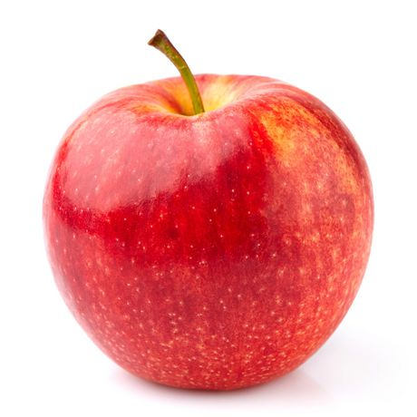
Herefordshire Live 2019
The first in a new series of live shows based in the beautiful county of Herefordshire. Grab your cider and get ready for a fun filled show!

Basic Info
Date: 21st July 2019
Location: Edwyn Ralph Village Hall, Edwyn Ralph
Doors Open: 8.30am
Start Time: 9.30am
Sections: Original Finish, Custom Finish, CTF, Animal Artistry, Performance & Workmanship
Chosen Charity: DOTS (https://www.dogsonthestreets.org/)
Contact: competitions@chestnutridge.co.uk
We will be applying for BMECS qualification

The Cost
Full Table: £15.00
Half Table (less than 20 models): £10.00
Proxy Fee: £5.00
Spectators: £2.00 each

Entry Terms
- Entry fees are 100% non-refundable under any circumstances – once you have paid you have made a commitment to attend the show
  - Excess entry fees will be donated to the chosen charity
- Failure to attend (either dropping out last minute, not turning up on the day etc) could result in your place being forfeited at future shows without a refund.
- No deposits will be taken, full payment only secures your space
All full table entrants will get one full table, please make sure to keep your boxes under your table!
Half table entrants may have to share a table or be given a smaller table depending on table numbers.
Now onto the more fun bit – please do not let the above put you off, sadly we had a lot of issues last year and we have had to be quite strict, this ensures that the show is full and that everyone who attends wants to be there.

The Schedule

Original Finish
- Arabian
- Thoroughbred
- Warmblood/Sport Horse
- Iberian
- Other European Light Horse
Light Horse Championship
- American Quarter Horse
- Appaloosa
- Paint
- Gaited
- Other American
American Championship
- British Native Pony
- European Pony
- Other Purebred Pony
- UK Heavy Horse
- Other Purebred Heavy Horse
Pony and Heavy Championship
- Donkey, Mule & Exotic
- Fantasy & Decorator
- Partbred Horse
- Partbred Pony
- Other Purebred Horse
Other Championship
- Light Youngstock
- Pony Youngstock
- Heavy Youngstock
- Partbred Youngstock
- Other Youngstock (inc. other equine & fantasy)
Youngstock Championship

Original Finish Championship

Custom Finish
- Arabian
- Thoroughbred
- Warmblood/Sport Horse
- Iberian
- Other European Light Horse
Light Horse Championship
- American Quarter Horse
- Appaloosa
- Paint
- Gaited
- Other American
American Championship
- British Native Pony
- European Pony
- Other Purebred Pony
- UK Heavy Horse
- Other Purebred Heavy Horse
Pony and Heavy Championship
- Donkey, Mule & Exotic
- Fantasy & Decorator
- Partbred Horse
- Partbred Pony
- Other Purebred Horse
Other Championship
- Light Youngstock
- Pony Youngstock
- Heavy Youngstock
- Partbred Youngstock
- Other Youngstock (inc. other equine & fantasy)
Youngstock Championship

Custom Finish Championship

CTF
- Arabian
- Thoroughbred
- Warmblood/Sport Horse
- Iberian
- Other European Light Horse
Light Horse Championship
- American Quarter Horse
- Appaloosa
- Paint
- Gaited
- Other American
American Championship
- British Native Pony
- European Pony
- Other Purebred Pony
- UK Heavy Horse
- Other Purebred Heavy Horse
Pony and Heavy Championship
- Donkey, Mule & Exotic
- Fantasy & Decorator
- Partbred Horse
- Partbred Pony
- Other Purebred Horse
Other Championship
- Light Youngstock
- Pony Youngstock
- Heavy Youngstock
- Partbred Youngstock
- Other Youngstock (inc. other equine & fantasy)
Youngstock Championship

CTF Championship

Performance
- English Ridden Horse/Pony
- Jumping
- Dressage
- Racing
- Other English Performance
English Performance Championship
- Western Pleasure
- Western Games
- Western Trail
- Cutting & Roping
- Other Western Performance
Western Performance Championship
- Costume
- Fantasy
- Driven
- Scene
- Other Performance
Other Performance Championship

Performance Championship

Workmanship
- Bay
- Black
- Chestnut
- Grey
- Non-Equine
Solid Colour Championship
- Bay Pinto
- Black Pinto
- Other Pinto
- Leopard Spotted
- Other Spotted
Part Colour Championship
- Dun
- Single Cream Dilutes
- Fantasy/Decorator
- Medallion/Bust
- Other Colour
Other Colour Championship

Animal Artistry
- Arabian Stallion
- Arabian Mare/Gelding
- Andalusian/Lusitano/Lipizzaner
- Thoroughbred/Warmblood/Sport Horse
- Other Purebred Horse
Light Horse Championship
- Stock Horse
- Gaited
- Other American
- UK Heavy Horse
- Other Heavy Horse
American & Heavy Championship
- Welsh A & B
- Welsh C & D
- Shetland & Highland
- Other European Native Pony (inc. other British native)
- Other Purebred Pony
Pony Championship
- Riding & Working Hunter Pony
- Hairy Cobs
- Other Cobs
- Other Partbred Pony
- Other Partbred Horse
Partbred Championship
- Mule
- Other Equine
- Fantasy
- Decorator
- Foals & Youngstock
Other Championship

Animal Artistry Championship

SUPREME CHAMPIONSHIP

Lunchtime Fun Classes
- Best Hereford Cow/Bull/Calf
- Herefordshire Made (any model horse made in Herefordshire)
- Apple most like horse

Donations
This is a charity live so all donations will be greatly received. We are looking for:
- Raffle Prize Donations
- Rosettes/Trophies
- Donation Sales Donations
- Certificates
- Food
- Anything else you think you can donate

Raffle and Sales
There will be a raffle at lunch time – tickets will be priced at £1.00 per strip.
There will be space for sales at lunch

Rules and Entry
- This is an open show and therefore anyone may enter.
- 3 entries per entrant per in hand class
- 2 entries per performance & workmanship class
- Each horse can only enter one breed class.
- Halters are allowed in breed classes but please no other tack or handlers
- Riders/handlers are mandatory in all performance classes with the exception of scene where not appropriate.
- No running, dogs or smoking is permissible in the hall.
- Take care when placing or removing horses from the ring.
- Do not touch or move any other model unless you have express permission to do so.
- Poor sportsmanship will not be tolerated. You will be asked to leave with no refunding of entry fee.
- The judge’s decision is final.
- Any queries regarding the show or classes should be directed to the show holders.
- Children under 13 years must be accompanied by an adult.
- Please sit at your own table throughout the show, do not place models on the floor or move them to another showers table.
- The organiser’s, their agents, nor the owner of the hall, will be held responsible for any theft, damage or personal injury.
- Please bring a packed lunch – snacks and drinks will be provided
- Data protection
  - For the purposes of this show your name will be stored on a spreadsheet in order to keep a record of who is attending
  - Following the show results will be typed up, posted onto the Facebook group and submitted to BMECS these will include your horse’s name and initials. If you do not want this information submitted then simply do not fill in your results, but please note this does invalidate your BMECS entry
  - Photographs will be taken both by the show holder and other entrants throughout the show which may be shared online/through social media. If you do not want your horses photographed then please indicate this clearly on a piece of paper when placing them into the ring.
- The show holder reserves the right to ask anyone to leave the show at any time without a refund of their entry fee. We WILL NOT tolerate poor sportsmanship, at all, ever.

Prizes & Sponsorship
- There will be certificates to sixth place
- There will be rosettes or trophies for champions
- Overall champions will get rosettes and possibly something else
  - Sponsorship Costs
- Class - £2.00
- Section - £20.00
- Championship - £10.00
- Alternatively if you donate the rosettes/prizes for a section/class/championship I will allow you to place advertising
- Sponsors get advertising in the show pack

Contact & Payment
Please make cheques payable to: Catriona Harris
PayPal payment (personal payment owed): rabbit.queen@hotmail.co.uk
  - Contact Details
Name: Catriona Harris
Email: competitions@chestnutridge.co.uk

Address:
Catriona Harris
30, Churchill Ave.
Leominster
Herefordshire
HR6 8JY

Directions

Edwyn Ralph Village Hall
Edwyn Ralph
Bromyard
Herefordshire
HR7 4LY
From Worcester (A44):
- Take the first turning on your right as you enter Bromyard (B4203)
- Take the first turning on the left up the high street
- At the end of the road turn left and then immediately right onto the B4214
- Continue along this road until you pass the Ralph Court Gardens on your right
- Take the third left after this onto ‘The Crest’
- The hall is on your right
From Droitwich (M5 J5)
- Following your sat nav from this direction will most likely result in you ending up on the B4203
- You can cut across narrow lanes cross country but for ease I would continue along this road until you reach Bromyard
- Continue along the road until you pass the post office (on your left) then take the first right
- Follow the directions above from step 3 (you will be on the high street)
From the B4214 (other direction to above)
- Take the first turning on the right as you enter Edwyn Ralph village
- If you reach Ralph Court gardens you have gone too far and will need to turn round

From B4214 Bromyard to Tenbury Wells Road, 3 miles from Bromyard to Edwyn Ralph. The village hall is signposted on the left.

Map
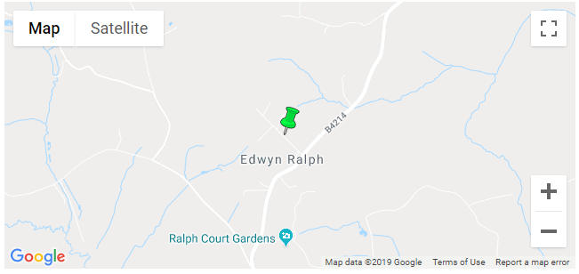
Larger more zoomed out map:
