Name of Breed
Add a photo here – I recommend you delete the black box!
Set the text wrapping on your image to “top and bottom”

Colour:
Height:
Conformation:

Use bullet points or short sentences – see the sample on the next page to help you.
If you have space you can include a brief sentence or two about the breed here, such as where it comes from, or what it is used for.

Before printing make sure to either delete the next page!

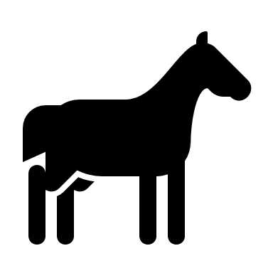
Sample Breed Card Example

Colour: Black – no white markings permitted
Height: 14.2hh – 17.2hh
Conformation: Elegant and strongly built; medium head with straight profile; short neck with little crest; short back; square croup; straight front legs; unusually bent back legs; short tail; shown hogged

The solid black horse is a rare breed of horse originating in the land of Microsfotovia. It is known for its distinctive straight front legs and strangely bent back legs. This unusual conformation produces the breeds distinctive gait the ‘hobble’. This gait often makes the horse look like it is about to collapse in pain but is actually quite natural and comfortable for the breed. They are often completely hogged and neither mares, stallions nor geldings are shown with a mane.

